**Sequence Diagram - Chat Privately**

Entity classes: Message

Boundary classes: PrivateChatView, NotificationView

Control classes: PrivateChatController

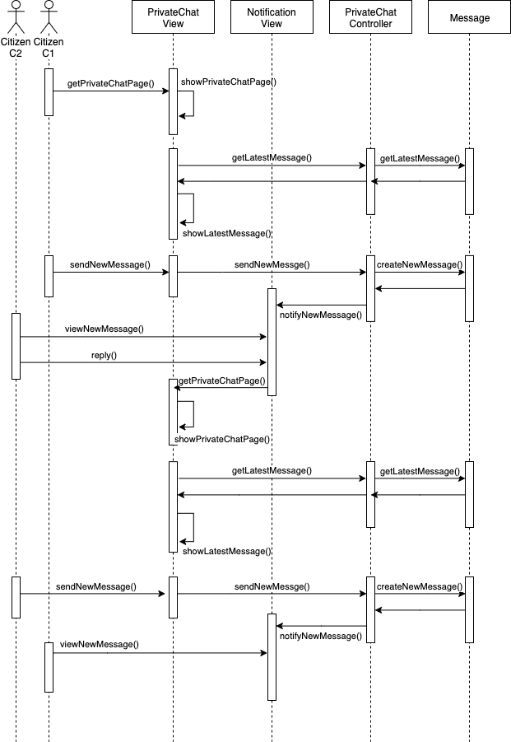

**Class Diagram - Chat Privately**

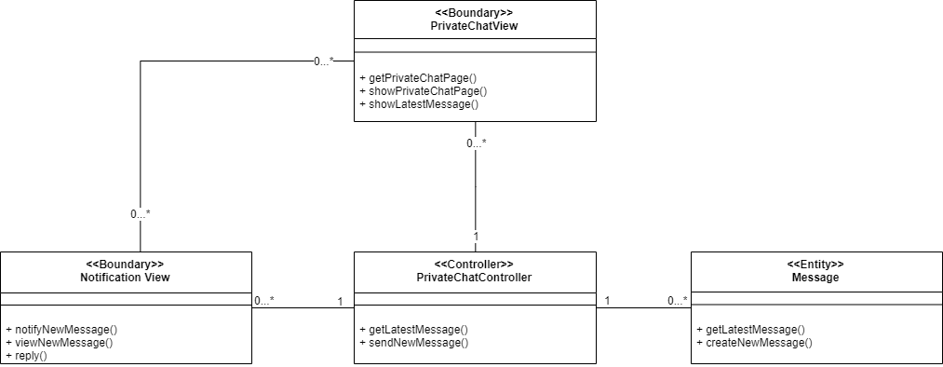

**Mapping between UML Diagram and Code Structure**

|  |  |  |
| --- | --- | --- |
| Analysis Class Type | Analysis Class | Corresponding Code Element |
| Boundary | PrivateChatView | frontend/page/privatechat.js |
| NotificationView | frontend/page/notificationview.js |
| Control | PrivateChatController | backend/controllers/chat.js |
| Entity | Message | backend/models/Messages.ts |